SOME OF THE METHODS WHERE LINQ USED IN HOTEL RESERVATION SYSTEM
1.In AdminUsersController LINQ is used to chain database operations:
Where filters the list to include only active users, OrderBy sorts them by ID for consistent display, and Select projects the data into a simplified UserDto format.
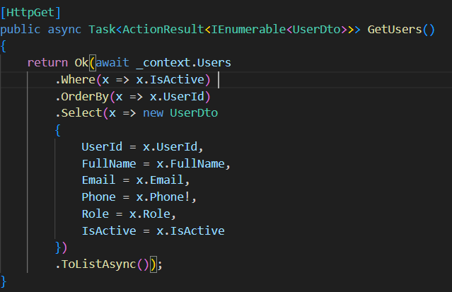
2.In ManagerReportsController LINQ is used for multi-step aggregation:
Where & Select: First, it finds all hotels assigned to the logged-in manager by filtering UserHotelAssignments with Where, then extracts just the HotelId list using Select.
CountAsync: It efficiently counts the total rooms for those specific hotels directly in the database without loading the room objects.
Include: Finally, when fetching reservations, Include eagerly loads related "Room" data so that nested properties (like room numbers) are available in memory for the subsequent stats calculation.

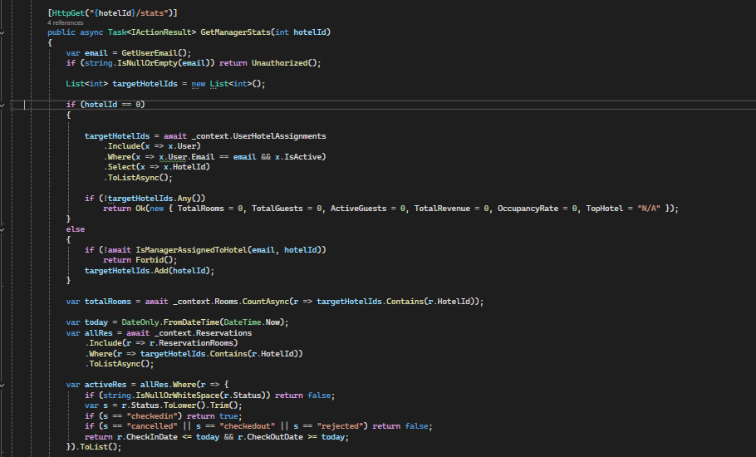

3.In this revenue trend query, LINQ constructs a targeted report: Include joins the Invoice data with Reservation details, Where strictly filters for "Paid" invoices within the target hotels and date range, and Select picks only the date and total amount. This minimizes data transfer by discarding all other invoice details before the result is returned from the database.
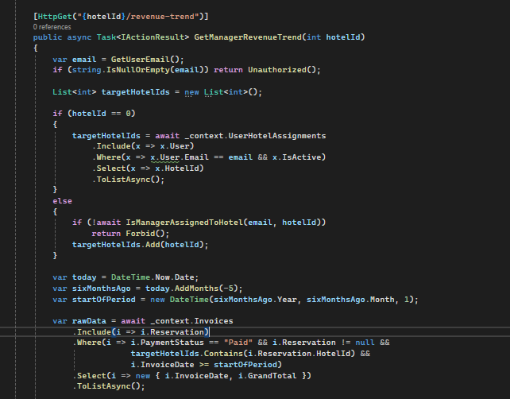

4.In ReservationsController, LINQ performs an in-memory join: GroupBy groups all invoices by ReservationId, and ToDictionary creates a quick lookup map. This allows the code to instantly match each reservation with its payment status (e.g., "Paid" or "Pending") without querying the database repeatedly for every single reservation.
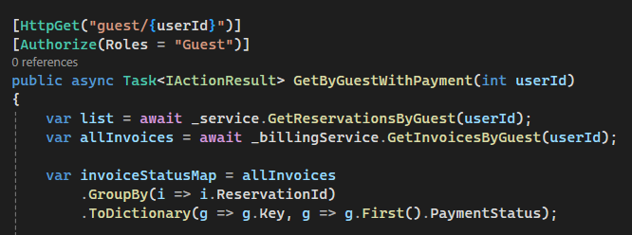

5.In CheckoutReminderService LINQ serves as a precise job filter: Where retrieves only reservations that are both "CheckedIn" and due exactly tomorrow, while AnyAsync inside the loop performs a fast existence check to prevent sending duplicate notifications to the same user within the last 20 hours.
